Project Design Phase-II

Data Flow Diagram & User Stories

|  |  |
| --- | --- |
| Date | 17 October 2022 |
| Team ID | PNT2022TMID17537 |
| Project Name | Project - A Gesture-based Tool for Sterile  Browsing of Radiology Images |

# Data Flow Diagrams:

A Data Flow Diagram (DFD) is a traditional visual representation of the information flows within a system. A neat and clear DFD can depict the right amount of the system requirement graphically. It shows how data enters and leaves the system, what changes the information, and where data is stored.

# Example: [(Simplified)](https://developer.ibm.com/patterns/visualize-unstructured-text/)

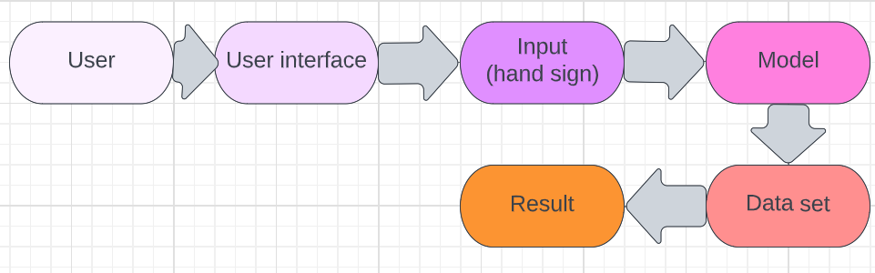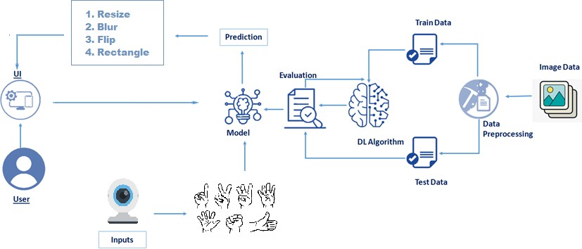

**User Stories**

Use the below template to list all the user stories for the product.

|  |  |  |  |  |  |  |
| --- | --- | --- | --- | --- | --- | --- |
| **User Type** | **Functional Requirement (Epic)** | **User Story Number** | **User Story / Task** | **Acceptance criteria** | **Priority** | **Release** |
| Customer  (Mobile user) | Registration | USN-1 | As a user, I can upload an image for  performing the action. | I can upload image | High | Sprint-3 |
|  |  | USN-2 | As a user, I can show my hand sign in front of the camera. | I can show hand sign | High | Sprint-1 Sprint-2 |
|  |  | USN-3 | As a user, I will send the result of the  uploaded image based on my hand sign. | I can get the result. | High | Sprint-2 |
| Customer (Web user) |  |  | same as a mobile user. |  |  |  |